1. Introduction

This section gives a scope description and overview of everything included in this SRS document. Also, the purpose for this document is described and a list of abbreviations and definitions is provided.

1.1 Purpose

The purpose of this document is to give a detailed description of the requirements for the “Amazing Lunch Indicator” (ALI) software. It will illustrate the purpose and complete declaration for the development of system. It will also explain system constraints, interface and interactions with other external applications. This document is primarily intended to be proposed to a customer for its approval and a reference for developing the first version of the system for the development team.

1.2 Scope

The “Amazing Lunch Indicator” is a GPS-based mobile application which helps people to find the closest restaurants based on the user’s current position and other specification like price, restaurant type, dish and more. The application should be free to download from either a mobile phone application store or similar services. Restaurant owners can provide their restaurant information using the web-portal. This information will act as the bases for the search results displayed to the user. An administrator also uses the web-portal in order to administer the system and keep the information accurate. The administrator can, for instance, verify restaurant owners and manage user information. Furthermore, the software needs both Internet and GPS connection to fetch and display results. All system information is maintained in a database, which is located on a web-server. The software also interacts with the GPS-Navigator software which is required to be an already installed application on the user’s mobile phone. By using the GPS-Navigator, users can view desired restaurants on a map and be navigated to them. The application also has the capability of representing both summary and detailed information about the restaurants.

1.3 Definitions, acronyms, and abbreviations

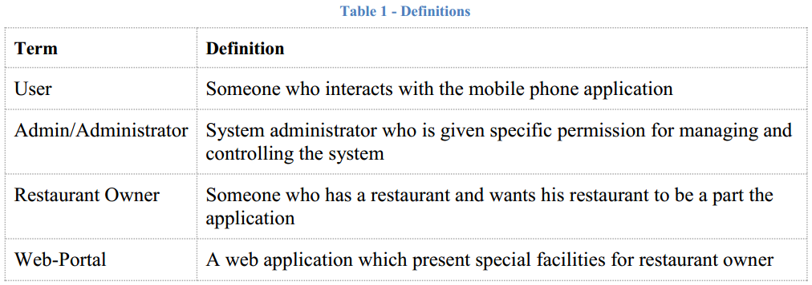

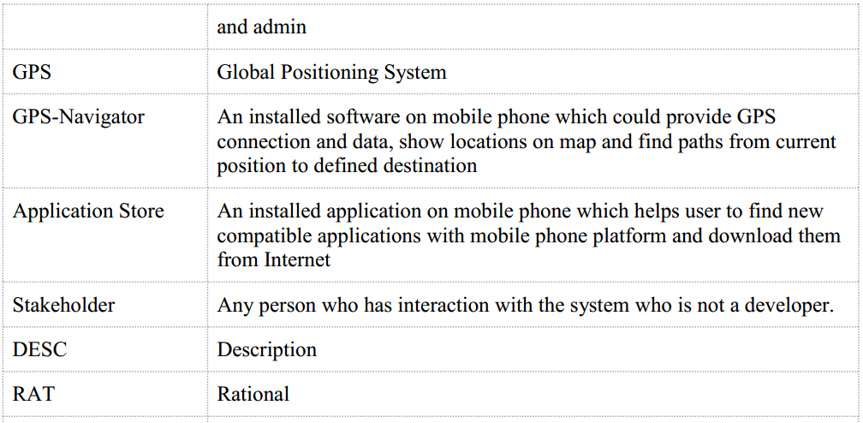

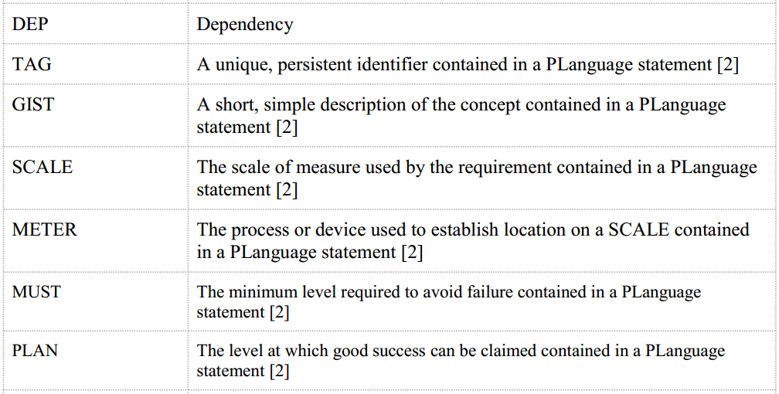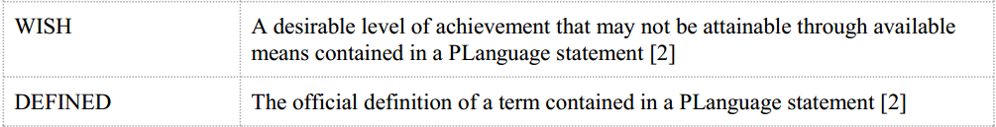

1.4 References

[1] IEEE Software Engineering Standards Committee, “IEEE Std 830-1998, IEEE Recommended Practice for Software Requirements Specifications”, October 20, 1998.

[2] Feldt R,”re_lecture5b_100914”, unpublished.

[3] Davis M A, “Just Enough Requirements Management: Where Software Development Meets Marketing”, New York, Dorset House Publishing, 2005.

[4] Karlsson J, “A Cost-Value Approach for Prioritizing Requirements”, Norges TekniskNaturvitenskapelige Uni. 1997

1.5 Overview

The remainder of this document includes three chapters and appendixes. The second one provides an overview of the system functionality and system interaction with other systems. This chapter also introduces different types of stakeholders and their interaction with the system. Further, the chapter also mentions the system constraints and assumptions about the product. The third chapter provides the requirements specification in detailed terms and a description of the different system interfaces. Different specification techniques are used in order to specify the requirements more precisely for different audiences. The fourth chapter deals with the prioritization of the requirements. It includes a motivation for the chosen prioritization methods and discusses why other alternatives were not chosen. The Appendixes in the end of the document include the all results of the requirement prioritization and a release plan based on them.